Van-Jordan Allen

Debrief

This Document contains all the information required by the Task 5 Assessment,  
here you’ll find (Screenshots, Links, Recourses, etc.) used to for the task.

Assessment Task 5

Document Version Control

**My GitHub Repository**

// -- [Version-Control-Assessment](https://github.com/Zappowa/Version-Control-Assessment) -- \\

(GitHub Online Repository)

These images show my GitHub Repository along with the linked URL on top.

The Repository Displays the number of commits at that current date also with any commits behind it or ahead.

(GitHub Online Repository)

Here shows a few of the many commits made throughout this task which range over multiple days/weeks the further you go back. If click on you may find yourself with more information on that commit like what changes were made or any bugs in that version.

(GitHub Desktop App)

With descriptions under most commits showing changes or something telling you why that commit was made to show good version control and keep everything clean.

(GitHub Desktop App)

Here shows more commits and descriptions/changes being made within these commits.

**Extra Screenshots For ^^**

Task 4 – Commits

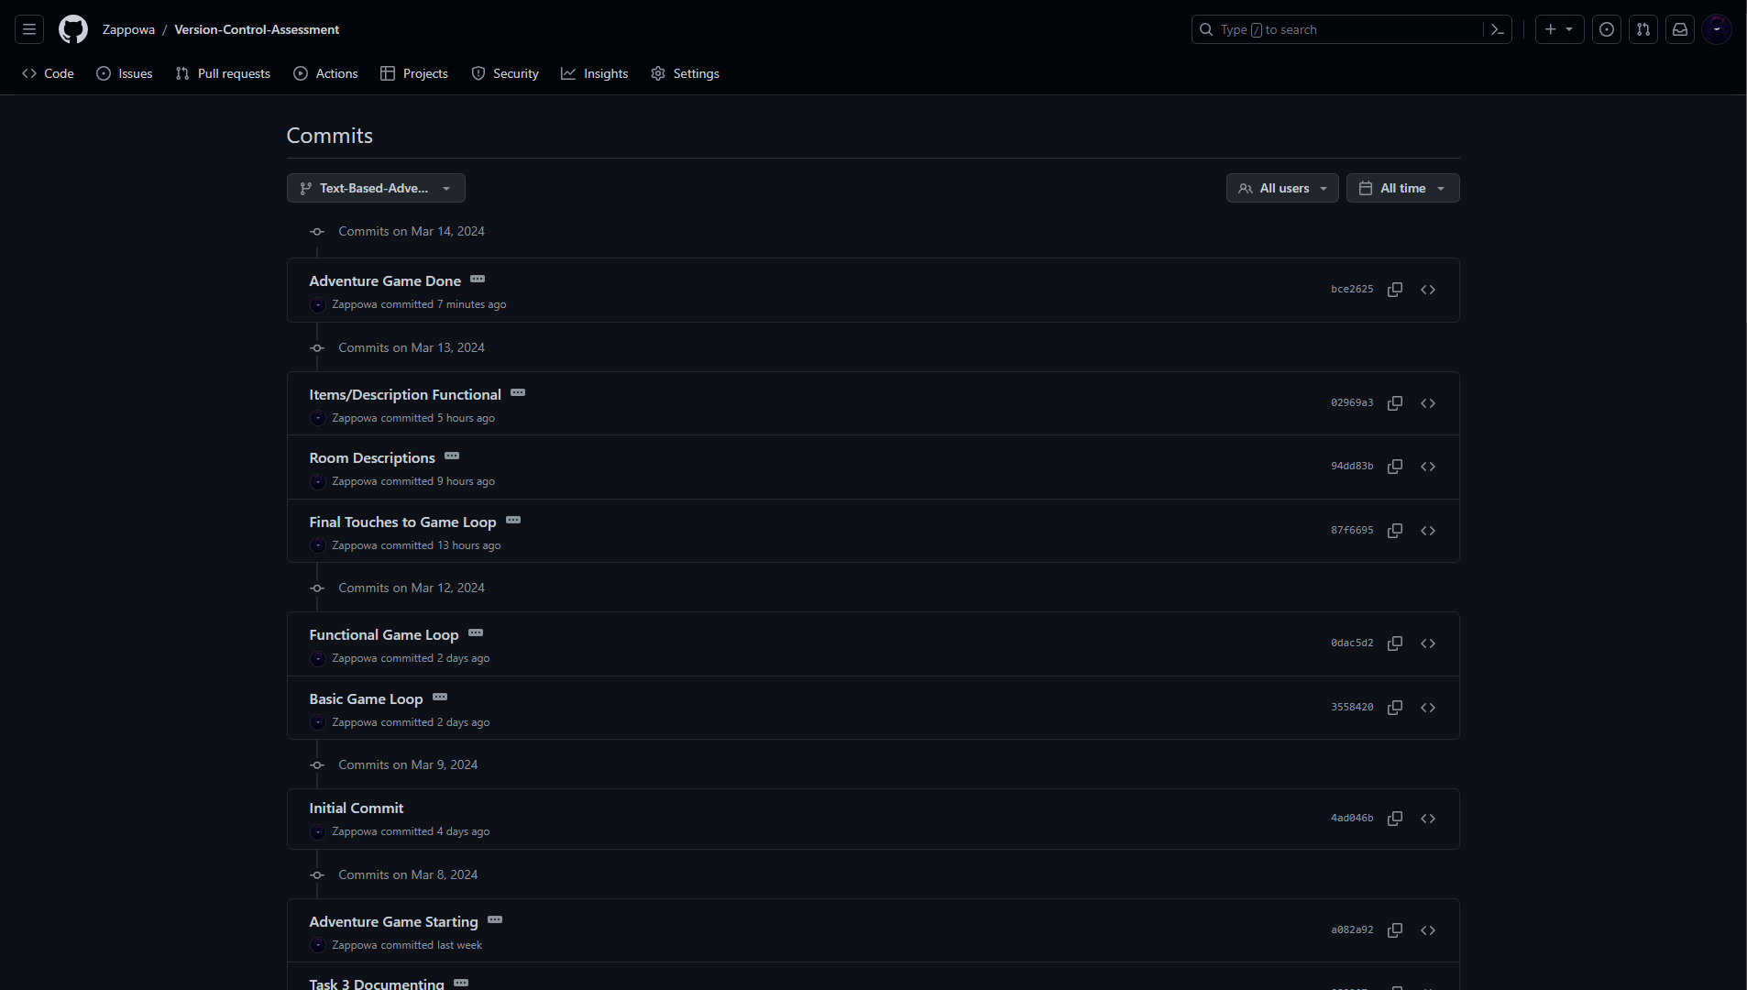

GitHub Branch's

